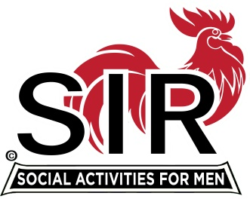
Las Trampas Branch 116
Meeting Agenda
August 16, 2021, 11:30 AM
The Mission of SIR is to enhance the lives of our members through fun activities, events and luncheons – while making friends for life

11:30 am Social Time Breakout Rooms
12:00 pm BIG SIR: Welcome and BIG SIR report
A - Branch news
B – Election of 2012 Officers and Directors
Nominations:
Fred Wachowicz [Big SIR],
Roger Craig [Little SIR],
Alan Fitzgerald [Treasurer],
Al Satake, David Ferm [Assistant Treasurers],
Paul Ramacciotti [Secretary],
Alan Pope [Assistant Secretary],
Phil Goff [Membership Secretary],
Mike Schneider [Assistant Membership Secretary],
Directors:
Al Farbman, Kevin Donahue, Darrell McClaughry, Don Benioff,
Dave Williams, and Samil Beret.

C – New Members
Bill Foulds Sponsor: Terry Sherman

Lyle Buckert Sponsor: Jack Minicucci

Bob Romero Sponsor: Don Schroeder

{underlined will be attending; sponsor intros}
12:15 BIG SIR: Activities Update [Mike Ward]
12:20 Paul Freitas Speaker Introduction
12:25 Speaker Matt Wachowicz
12:55 Little SIR Thank Speaker and announce lucky Birthday Boy
13:00 BIG SIR Closing Remarks
*********************************************************************************
Las Trampas Br. 116 Luncheon Meeting
Join Zoom Meeting on August 16, 2021 at 11:30 AM

https://us02web.zoom.us/j/89269854543
Meeting ID: 892 6985 4543
Passcode: 826904

Dial-in: (669) 900-9128

